Vaccine Web App

By

Sagar Singh

Level-6

Final Project

Table of Contents

Project Proposal 3

Goals and Objectives 3

Project Scope 3

Project Specifications 3

Target Audience 3

Project Deliverables 4

Resource Requirements 4

Project Tasks and Milestones 4

Project Assumptions 5

Project Report 5

Detail Design 6

Home Page 6

Signup Page 6

Signin Page 7

Add Item Sub Category Admin View 7

Orders Admin View 8

My Cart Page View 8

Item Sub Category  View 9

My Orders View 9

Project Testing 10

User Manual 10

Summary 10

System Configuration 10

User Access Levels 10

# 

# Project Proposal

## Goals and Objectives

The main goal or aim of the project is to implement an online web application named “Bike Store”. The main purpose of the application is providing a way to visitor view the Bike and their accessories details to enhance your riding experience. Visitor can also maintain cart and place the order of items selected. In this application there are two types of users- admin and registered visitor. Admin has different functionalities as compare to registered visitor. Admin can add, edit, delete and check details of all items available at store. Registered user can maintain their order and cancellation policy.

## Project Scope

The scope of this project is to implement an app named “Bike Store” with the help of which view the Bike and their accessories details to enhance your riding experience. The duration of the project is 20 working days which is equals to 4 weeks.

## Project Specifications

* Admin login/logout
* Add, edit, delete and check details of Categories and Sub Categories by admin.
* Admin can delete, edit and check Item available online.
* Admin can view order details of user which place the Order online.
* Admin can register new admins.
* Registered Visitor can login/logout.
* New Visitor can register.
* Registered Visitor can control their Order placed online.

## Target Audience

The target audience for this project is the people who want all bike and their component details online. The age can go from 18 plus to 100 plus.

## Project Deliverables

The deliverables of the project are:

|  |  |
| --- | --- |
| **Deliverable** | **Description** |
| Final Report | This will be the final report of the project. |
| Coding | The executable code of the project will go under this. |
| Documentation | This portrays the documentation of the project. |
| Testing | All the test details will be covered in this part. |

## Resource Requirements

* Windows Operating System.
* Microsoft word for documentation.
* Asp.net MVC Framework
* 64-bit Processor and 4 GB or more RAM
* Identity framework- ASP

## Project Tasks and Milestones

|  |  |  |  |  |
| --- | --- | --- | --- | --- |
| **Tasks** | **Week-1** | **Week-2** | **Week-3** | **Week-4** |
| Brainstorming and analysis |  |  |  |  |
| Planning and initial meeting Project Proposal document. |  |  |  |  |
| Database Design and UI Design |  |  |  |  |
| Identity framework implementation |  |  |  |  |
| Coding for admin and reporter |  |  |  |  |
| Testing |  |  |  |  |
| Final Documentation and closing |  |  |  |  |

## Project Assumptions

Following are the assumption made while implementing the project:

* One admin and registered visitor will be registered by default.
* Application will be free and open source.

# Project Report

#### Functional and Non-Functional

|  |  |
| --- | --- |
| Users | Functional |
| Admin | * Login/logout * Register new admins * Admin can add, edit, delete, check details for categories and sub categories of item. * Admin can edit, delete and check details for Item available store. * Admin can view personal details of user which place order online. |
| Customer | * Can view details of all items available online * Can control their order online and maintain his/her cart. * New customers can register for free. * Login using valid credentials |
|  | Non- Functional |
|  | * High speed * Fast Loading time * High performance and security * All browsers compatibility. |

## Detail Design

### Home Page

The main landing page of the application. On navigation bar options are- Home, Item Categories Link with drop down, Cart, Sign up, Sign in.

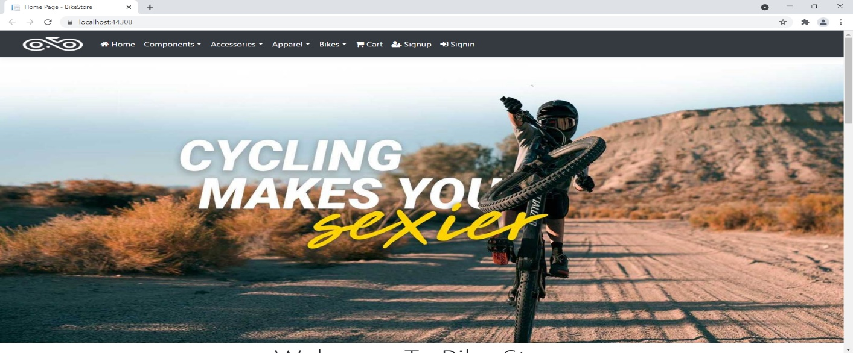

### Signup Page

With the help of this page, new visitor can register online

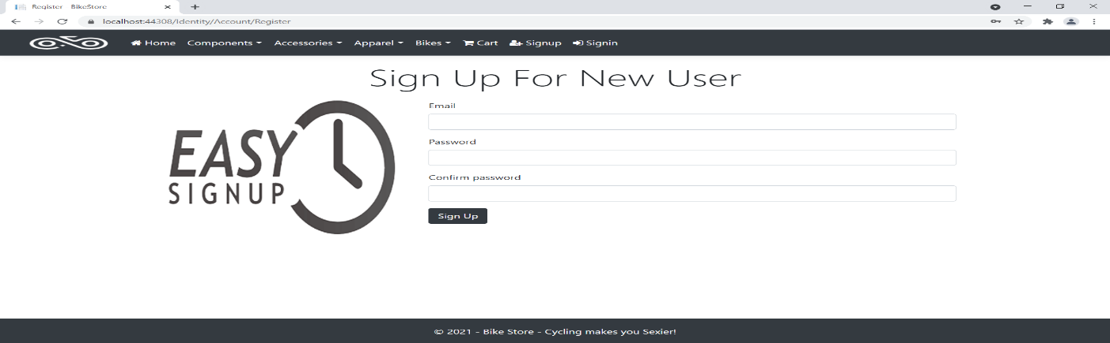

### Signin Page

With the help of this page, visitor can login to page and access unrestricted page.

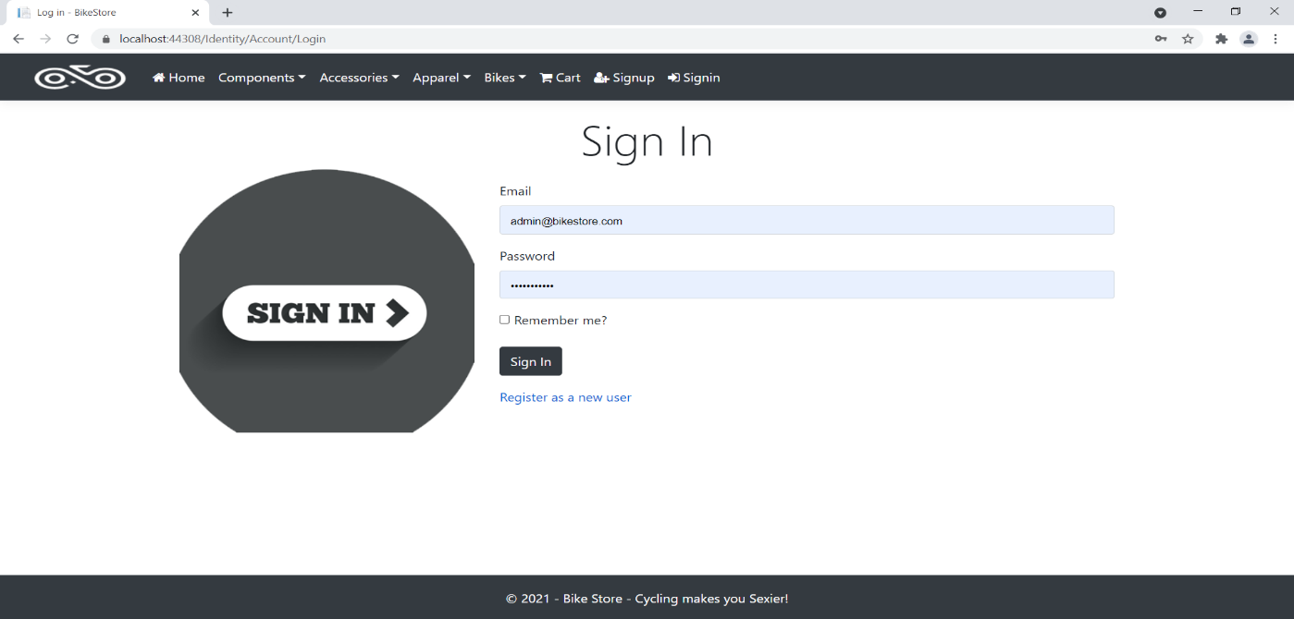

### Add Item Sub Category Admin View

This page provide a way to add new item sub category to online store.

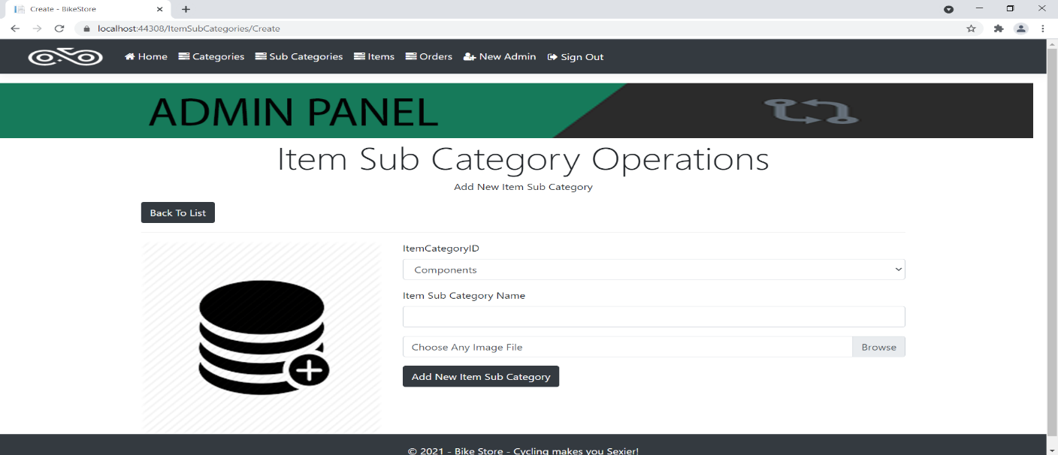

### Orders Admin View

With the help of this page admin can view personal details and link to order details of all order placed by registered user.

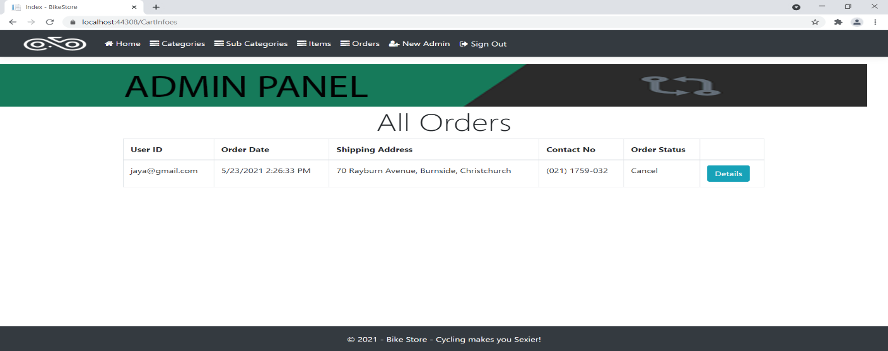

### My Cart Page View

With the help of this page Register user can view his/her cart details.

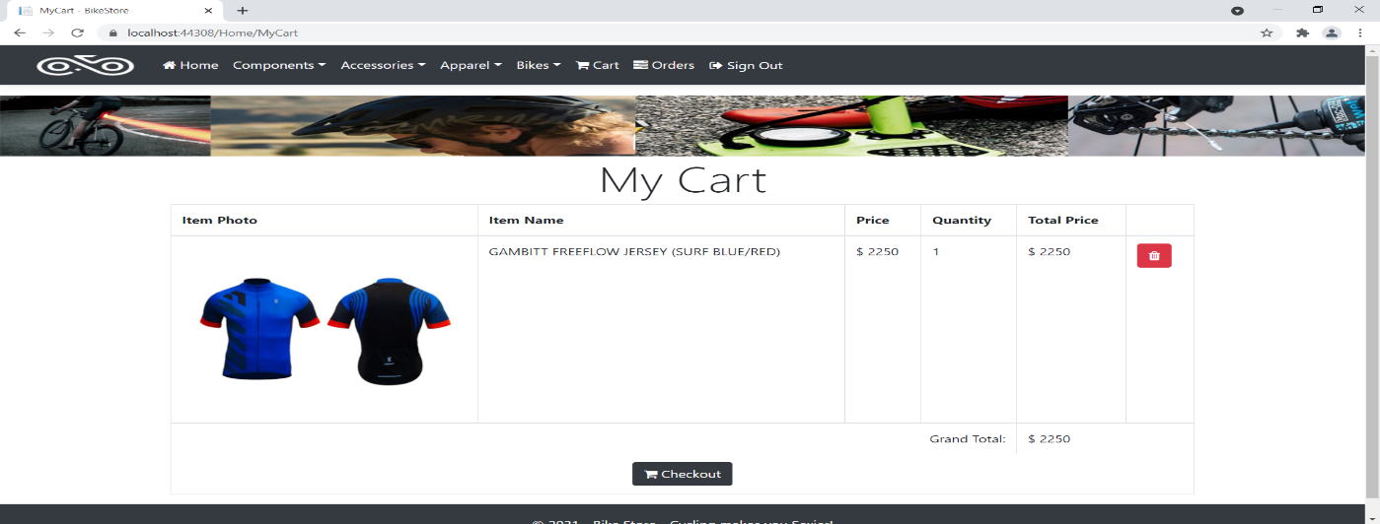

### Item Sub Category View

With the help of this page visitor can view all item sub category and link for view items related to this item sub category.

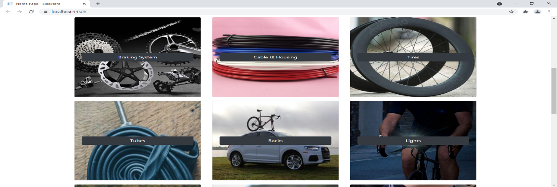

### My Orders View

This page shows the all order placed by registered user.

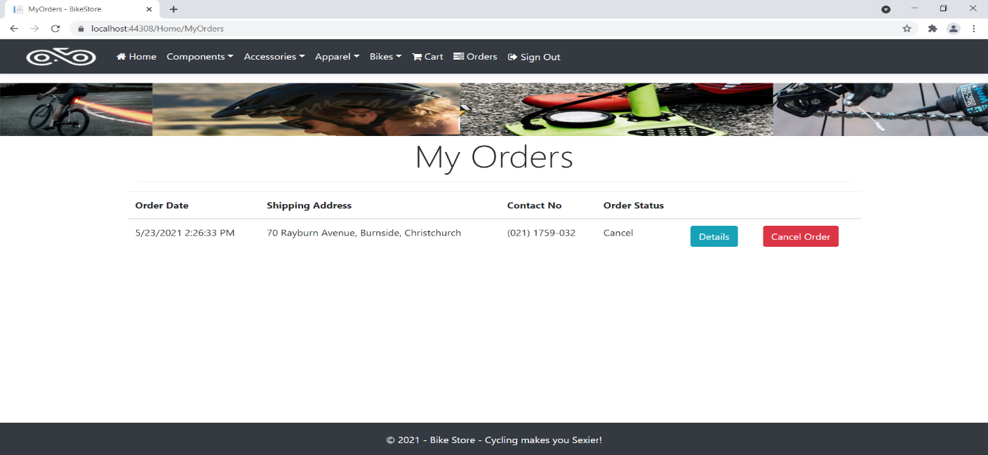

## Project Testing

The testing file for usability testing is attached as [usability test.xlsx](usability%20test.xlsx)

# User Manual

The main purpose of the application Bike Store is to help bike lover to ease their process of finding bike and their components. In this application there are two types of users- admin and registered user or visitor. Admin has different functionalities as compare to registered user. Admin can add, edit, delete and check details of items available at online bike store. Registered User is capable to maintain his/her cart, place order as well as their cancellation.

## Summary

### System Configuration

This app will be useful to for distributing mobile information in presentable format.

### User Access Levels

Only registered users can access the features of this application.

* **Admin:** Admin has full access of the app can register new admins.
* **Registered Visitor:** New visitor can register and existing can login using their own credentials. They have limited access.